What We Did in the Last Class
- We downloaded and installed the Tomcat server on our EC2 Linux instance.
- This server will help us run Java applications on the web.
What We’re Doing Now
- We will deploy a WAR file (Java application) on the Tomcat server.
What’s Already Done
- We converted our Java source code into a WAR file using Maven (a Java build tool).
- Tomcat server is successfully installed on our Linux-based system.

🌐 Why We Do This
- Once deployed, we can access our Java application (WAR file) through a web browser
Let’s connect with the Tomcat server which is in our Linux based Ec2 server/instance
execute or run this url in the browser Tab 3.110.88.1:8080
3.110.88.1 is the EC2 Instance public IP Address and 8080 is the port number Tomcat is running on.
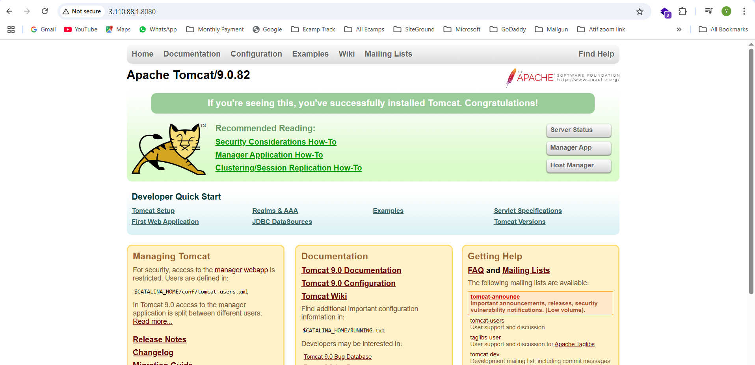
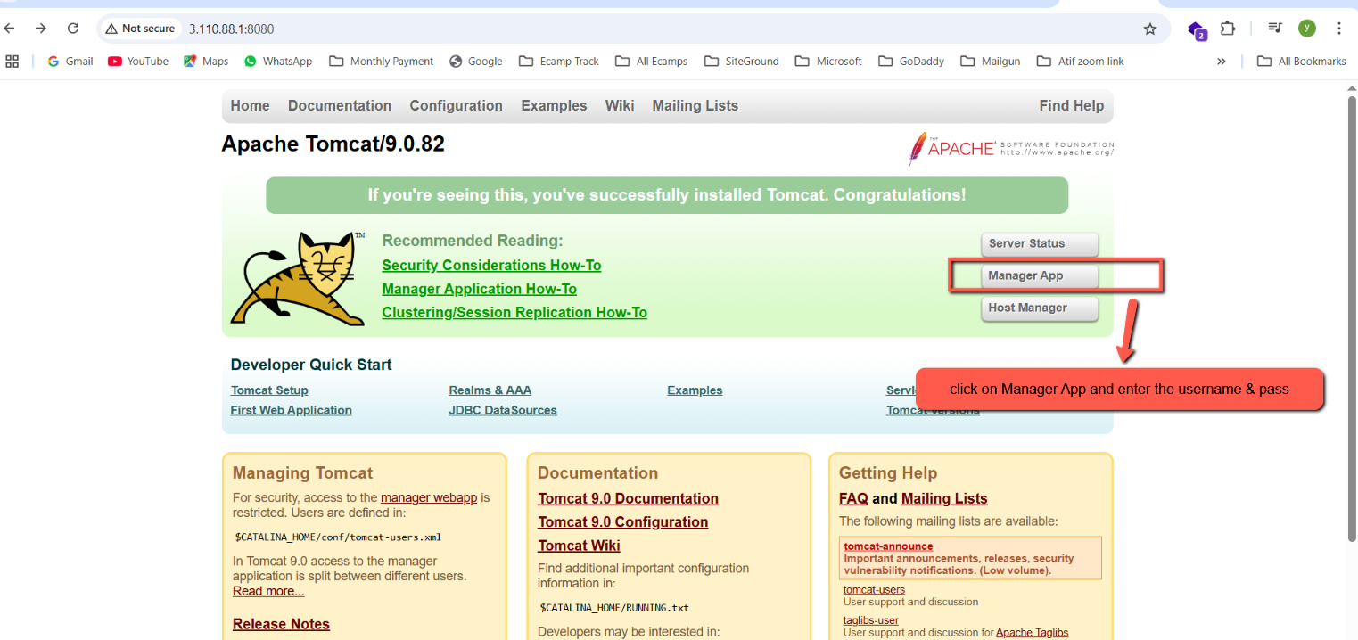
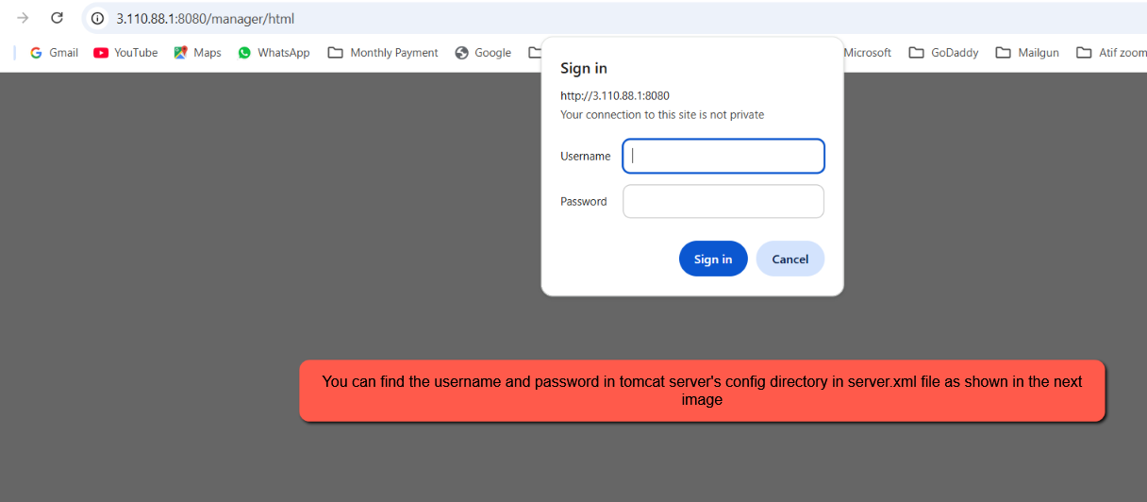

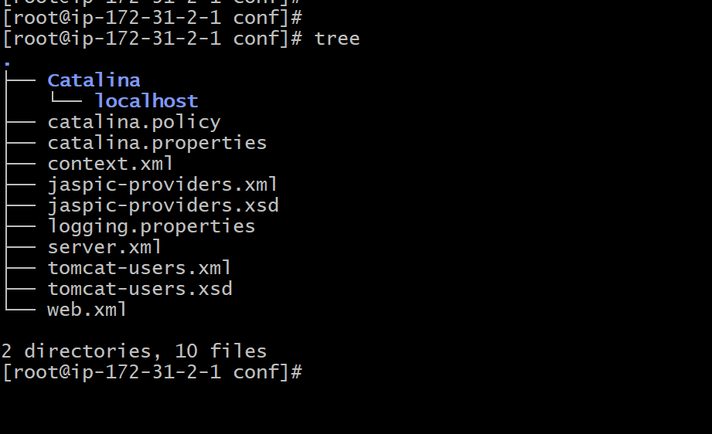

In conf open the tomcat-users.xml file and check the username and password
open the file by executing the command vi tomcat-users.xml
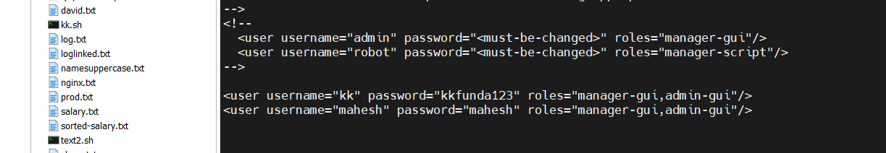

Download mobaxterm software from google
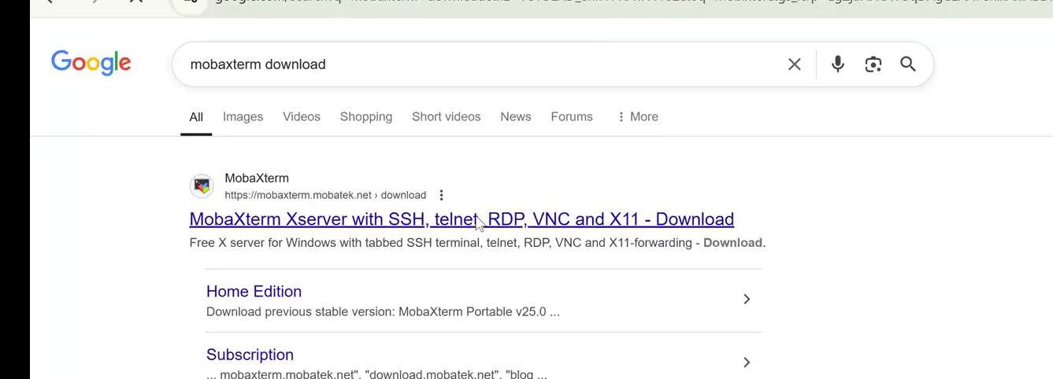

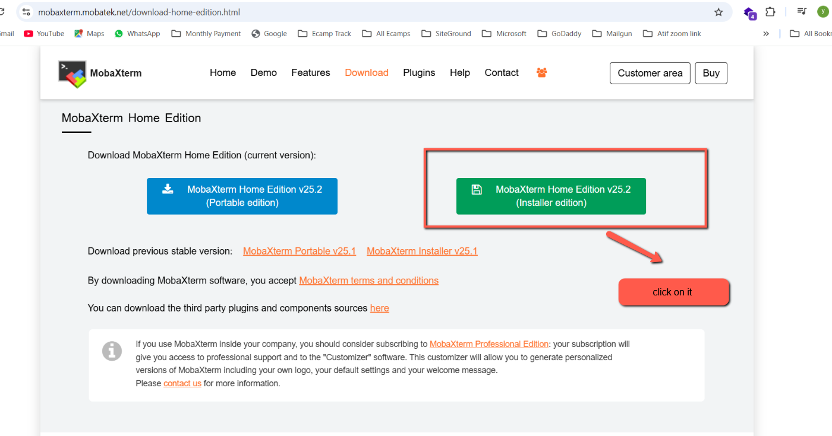
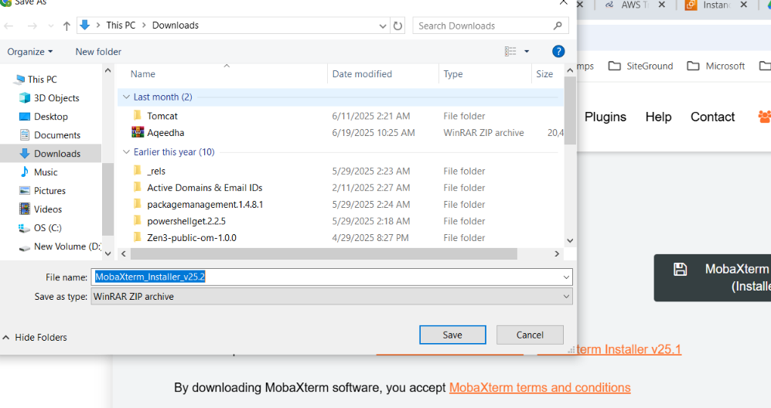
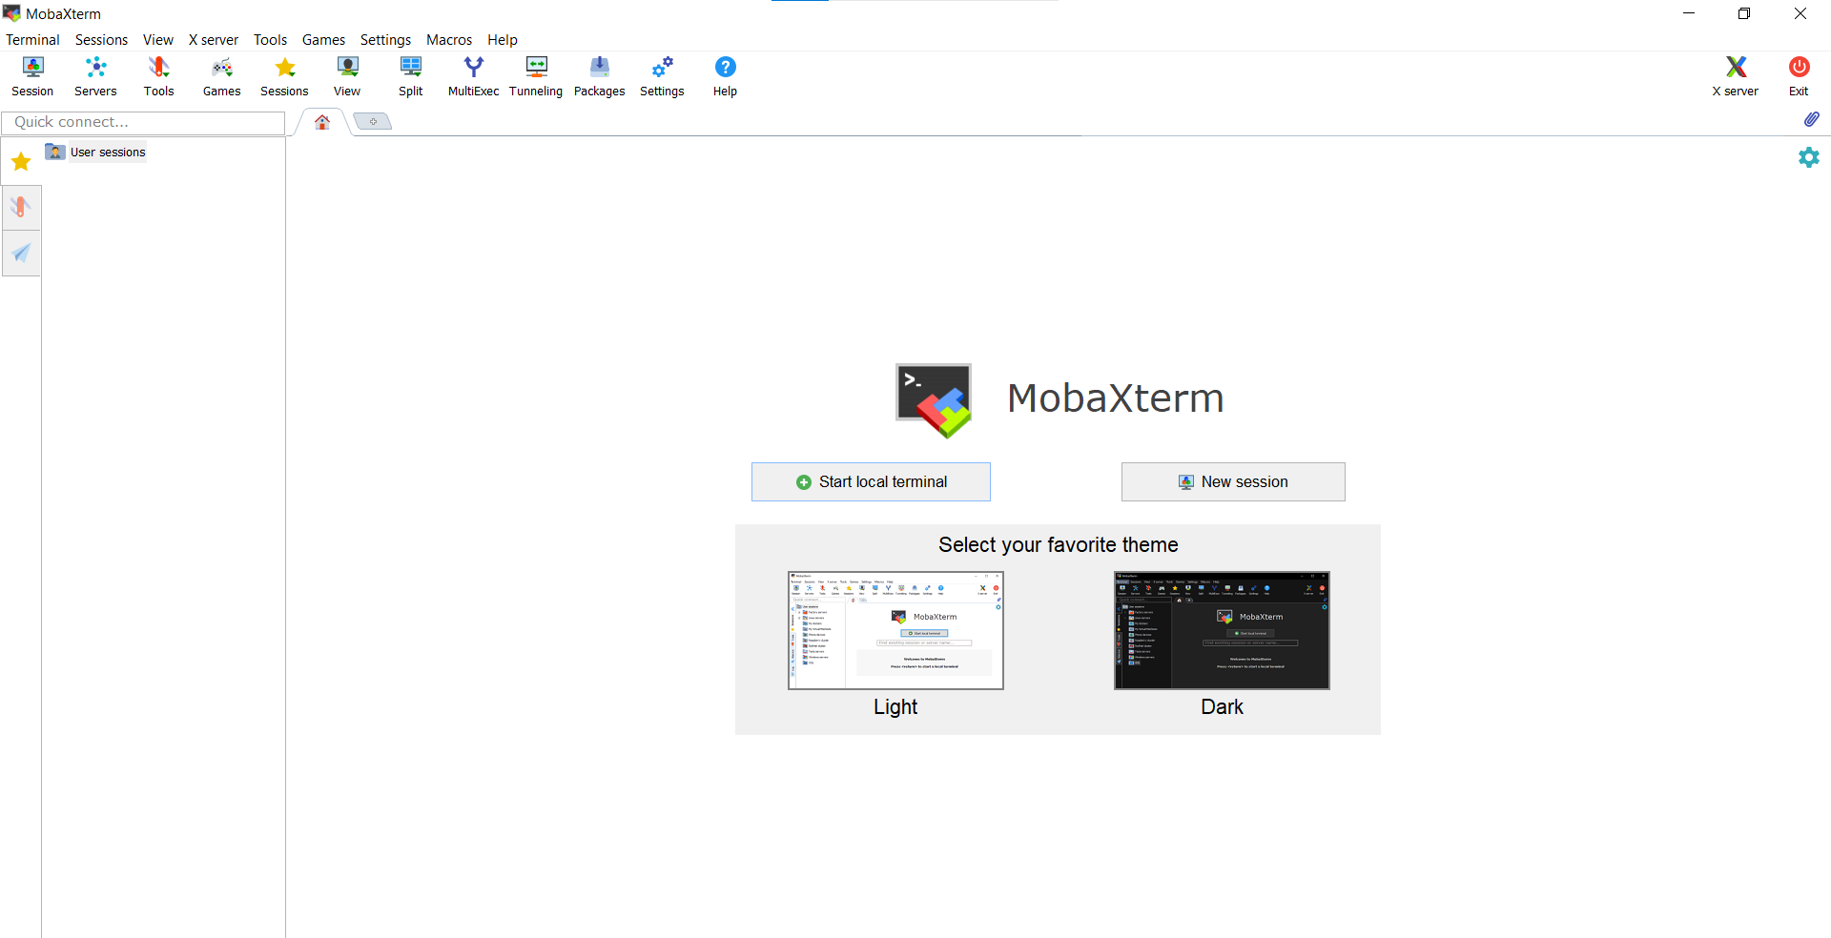
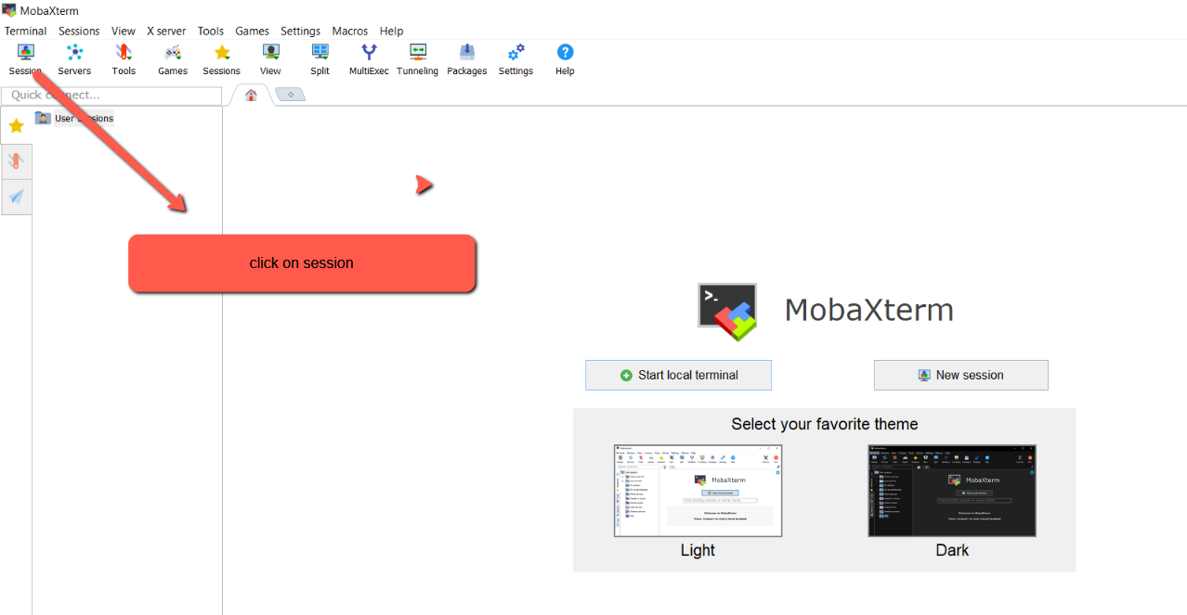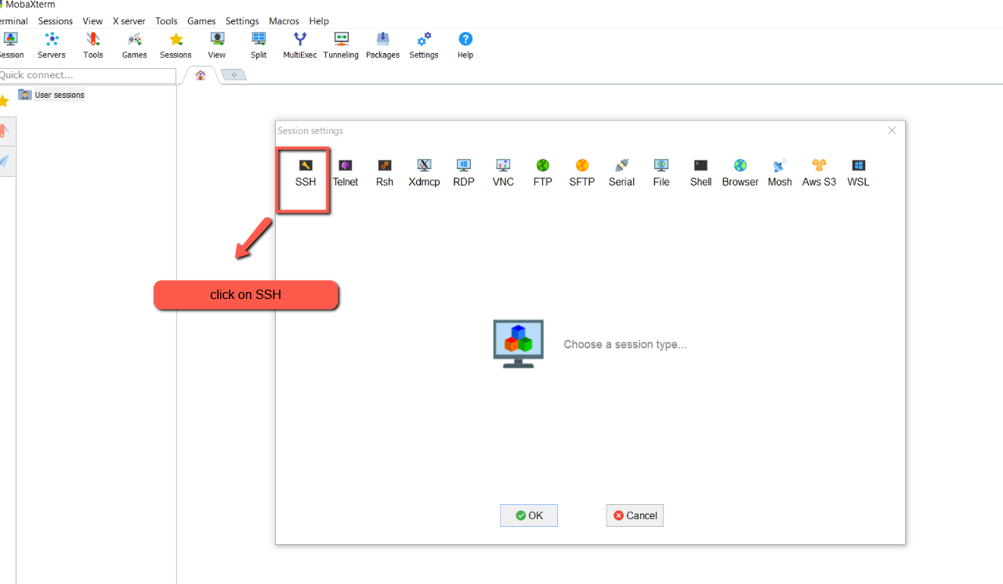
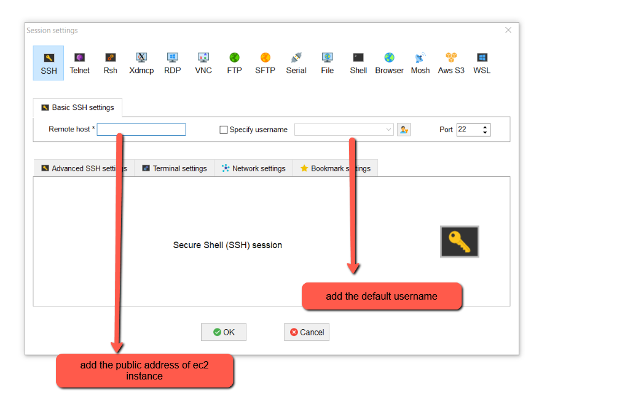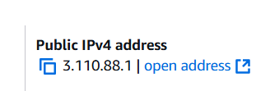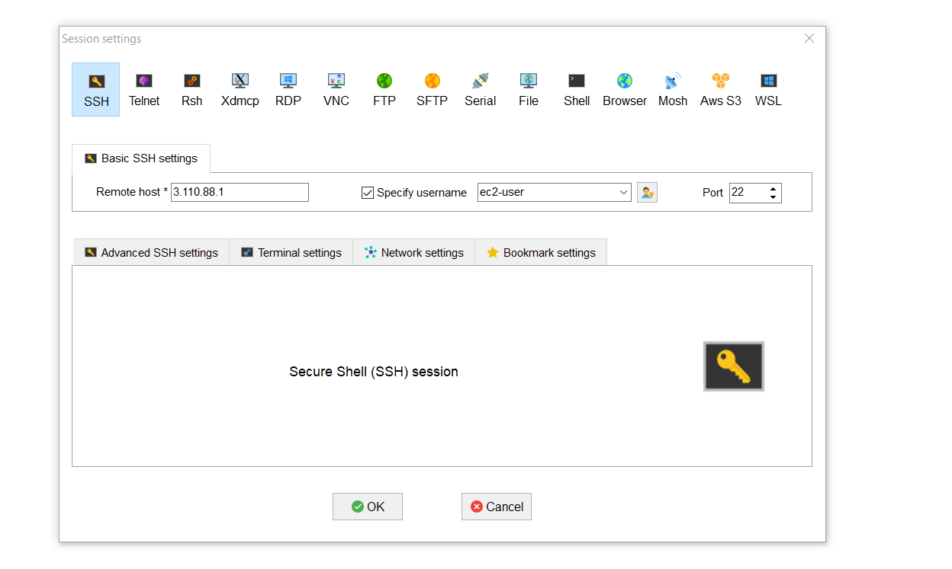

Next Click on Advanced SSH settings 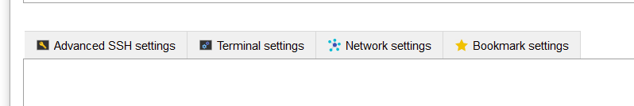
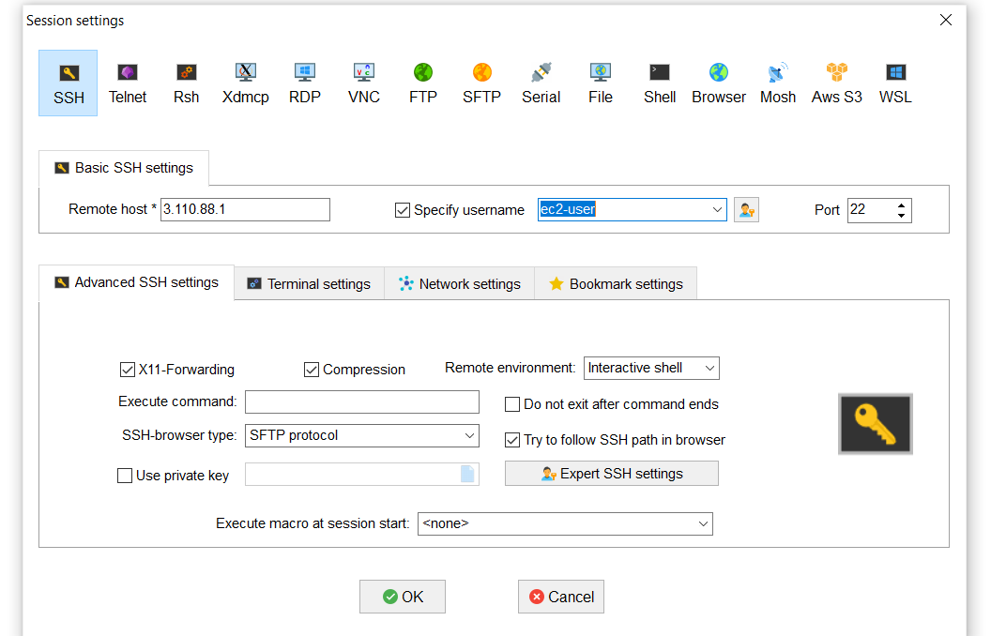
click on Use private key
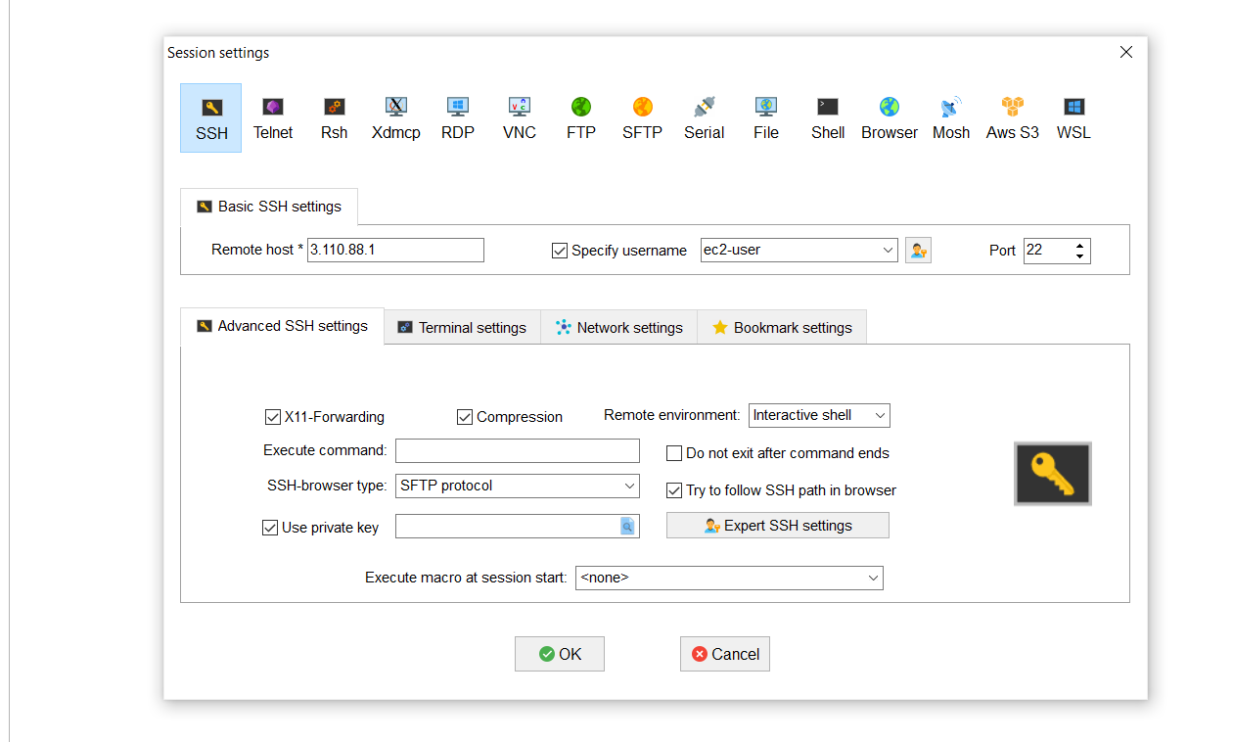
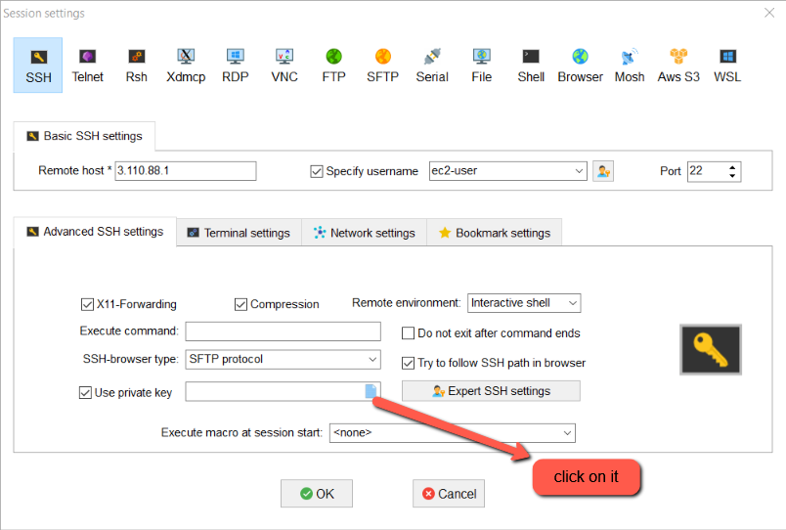
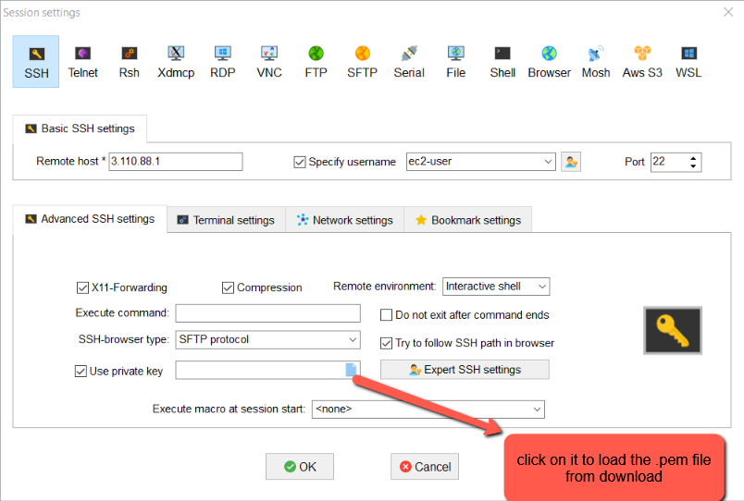
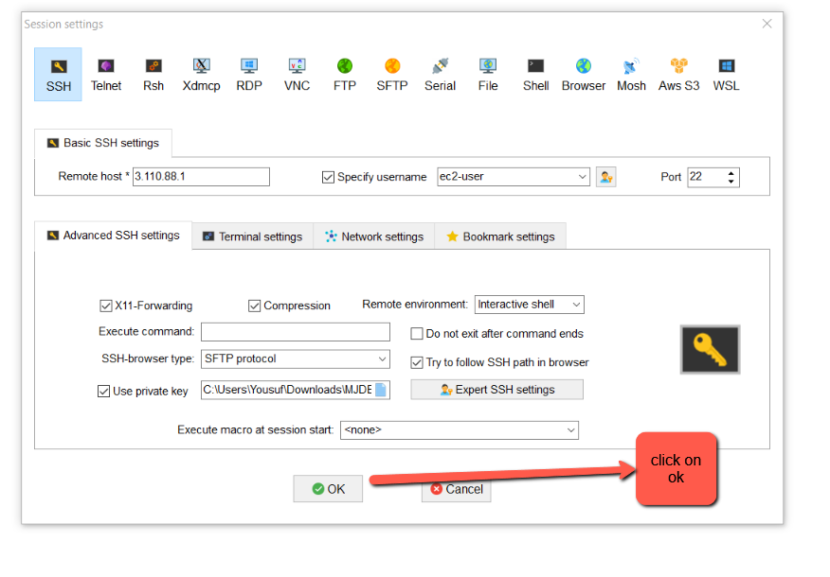
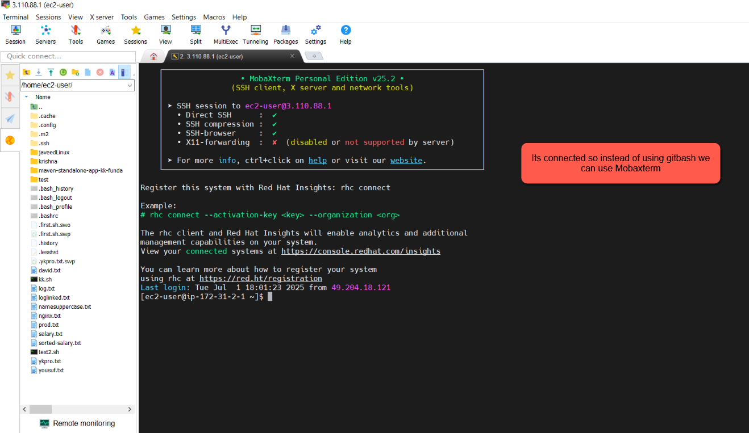
Now open the conf directory and then server.xml file to check the tomcat server login credentials
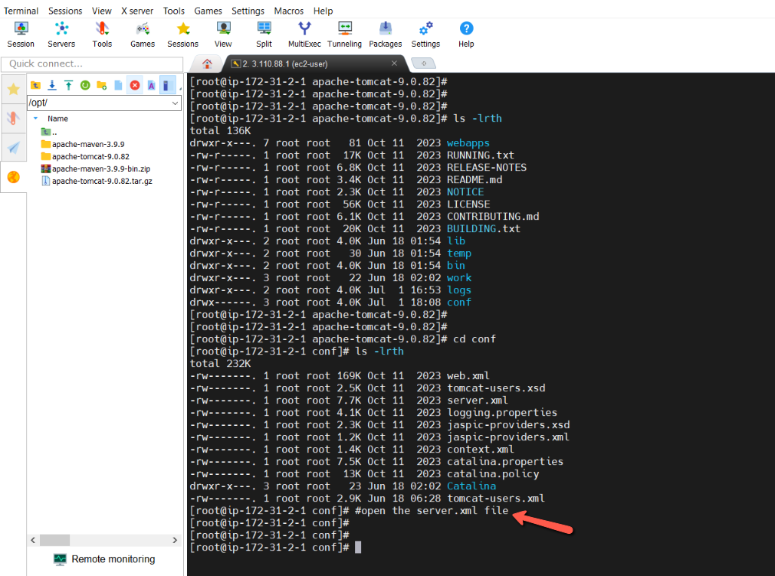
ps -ef |grep -i "tomcat"
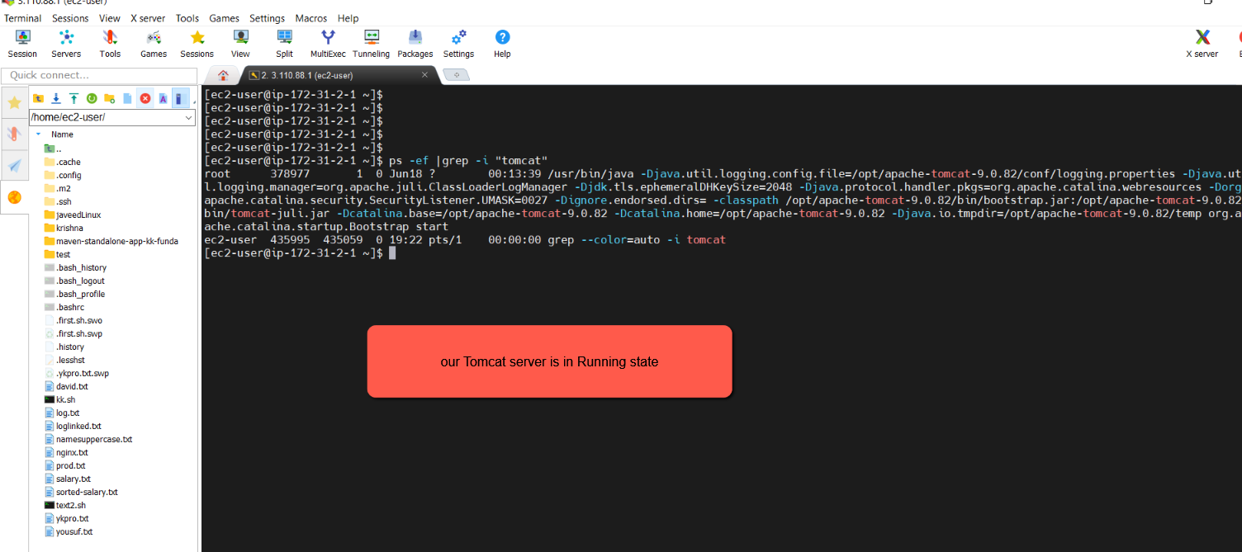
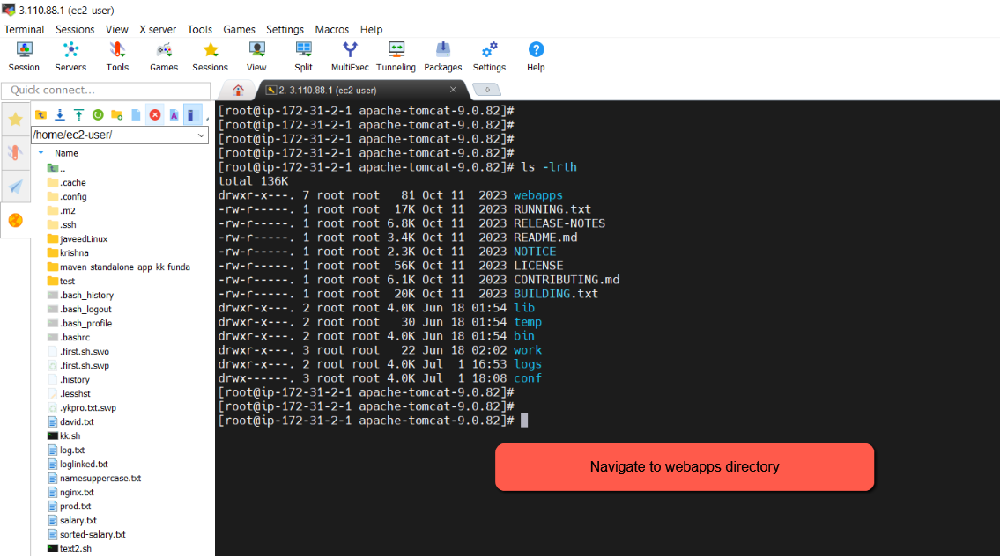
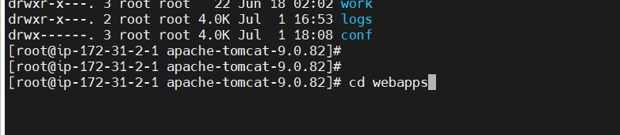
we already have presinstalled Application bydefault in webapps as shown in the below image
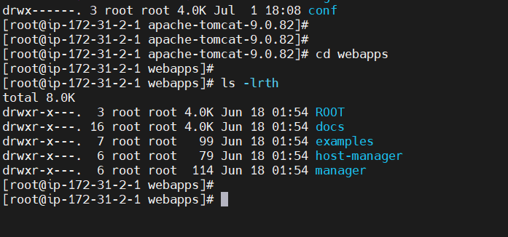
Lets try to deploy the war file from Maven in to Tomcat servers webapps directory
In the tutorial trainer prashant has created multiple Ec2 Instance servers 1)Maven 2)Tomcat
He explains how to move the war file from Maven Instance to Tomcat Instance using scp method
At: 14:26
But in our case we have installed both maven and tomcat in the same ec2 instance
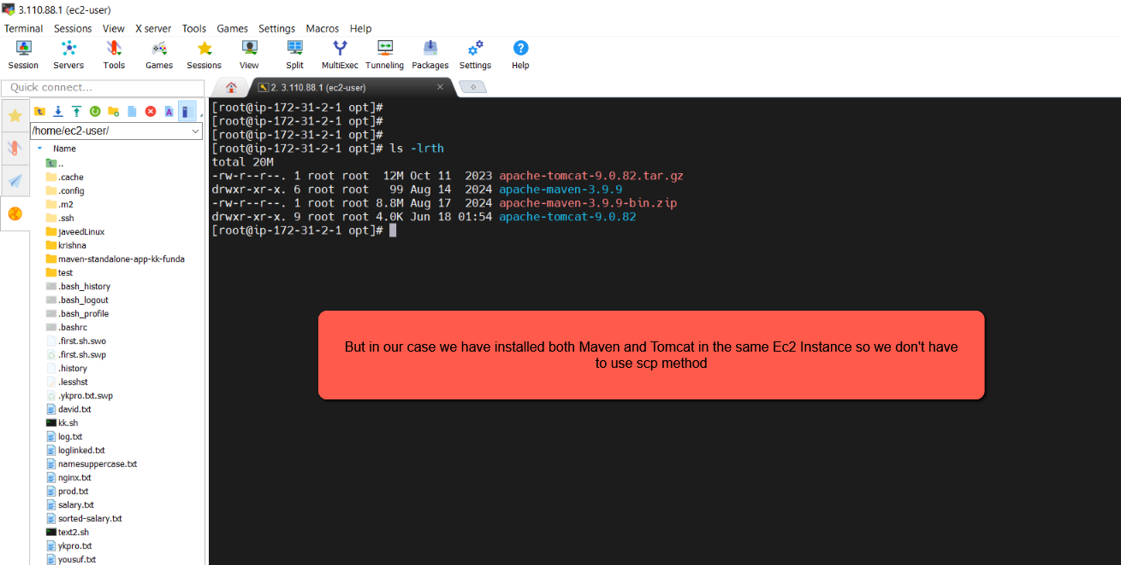
Navigate to ec2-user from root by executing the command cd /home/ec2-user
Then execute ls –lrth
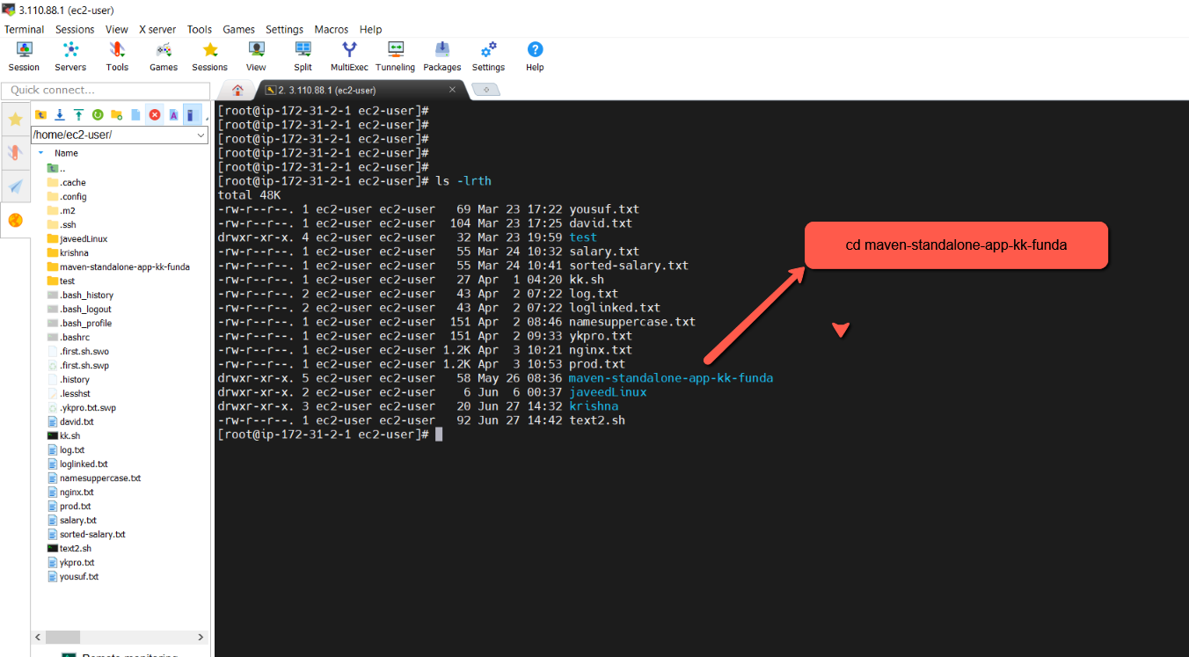
cd /home/ec2-user/maven-standalone-app-kk-funda
Then check list of file & folders
ls
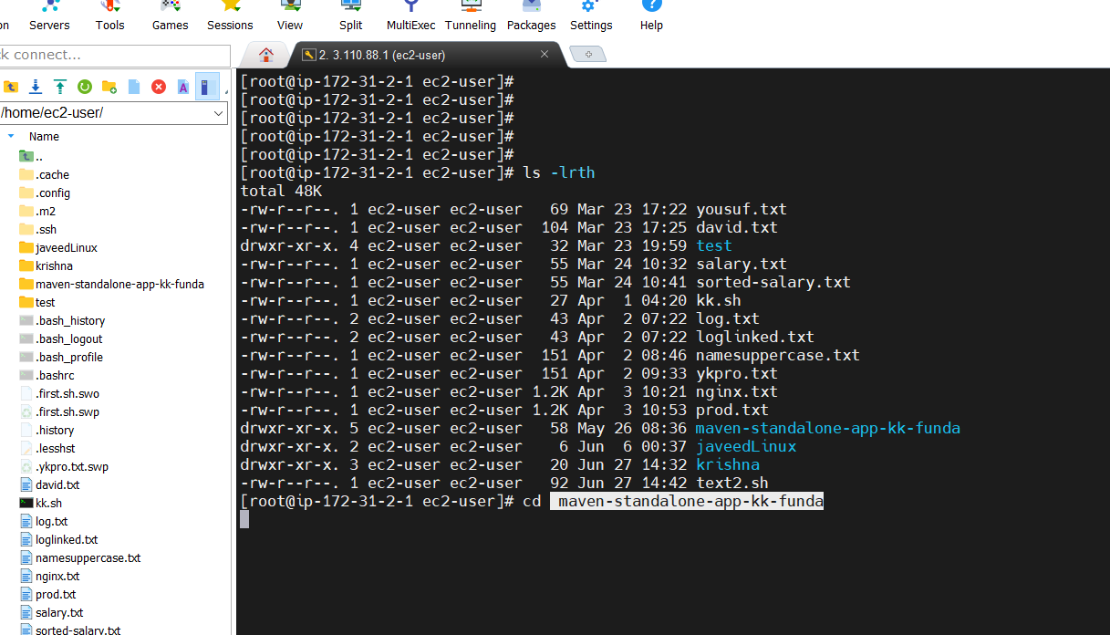
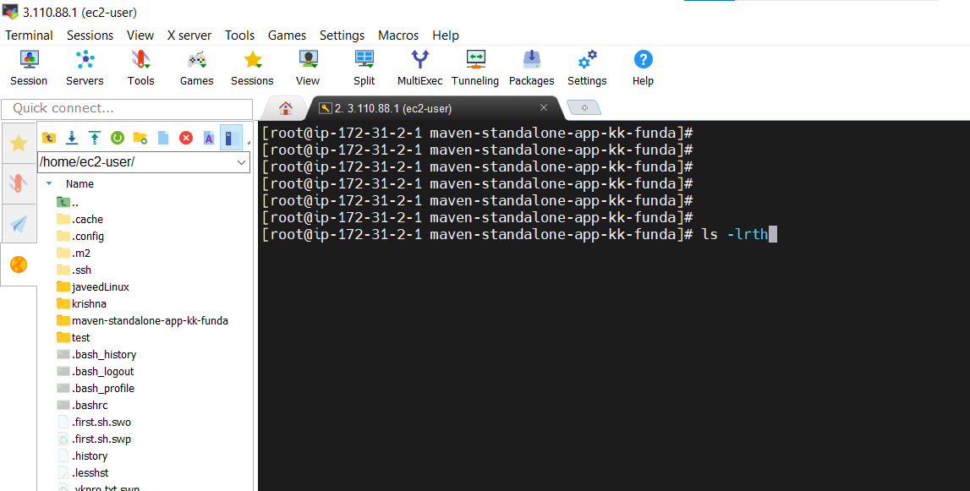
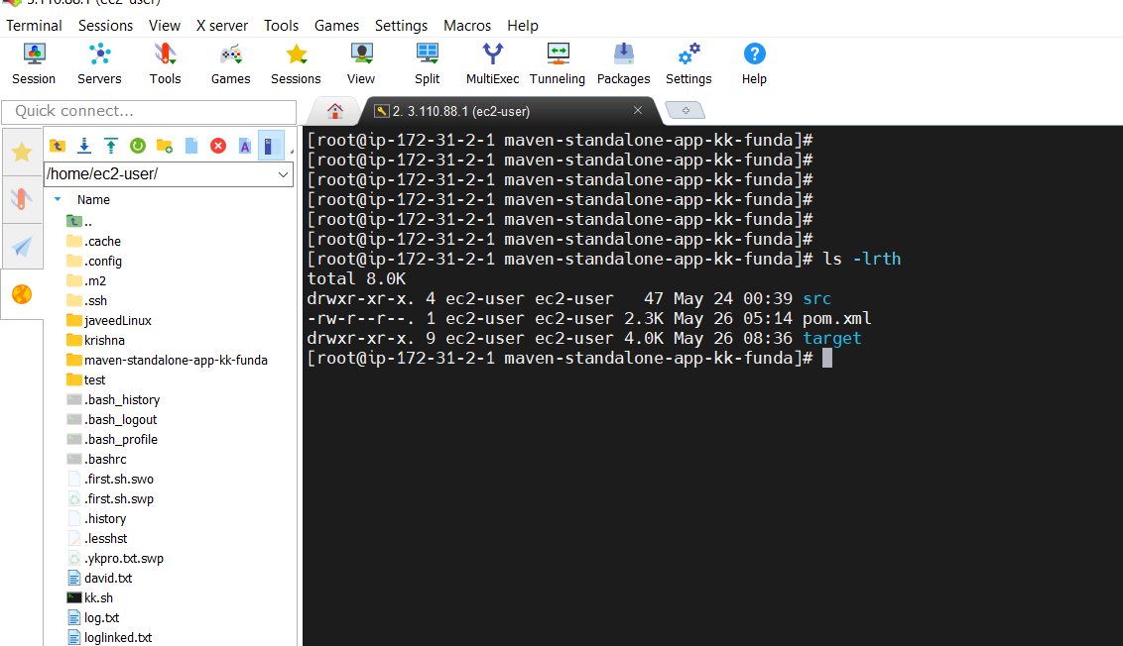
here execute the command mvn clean install
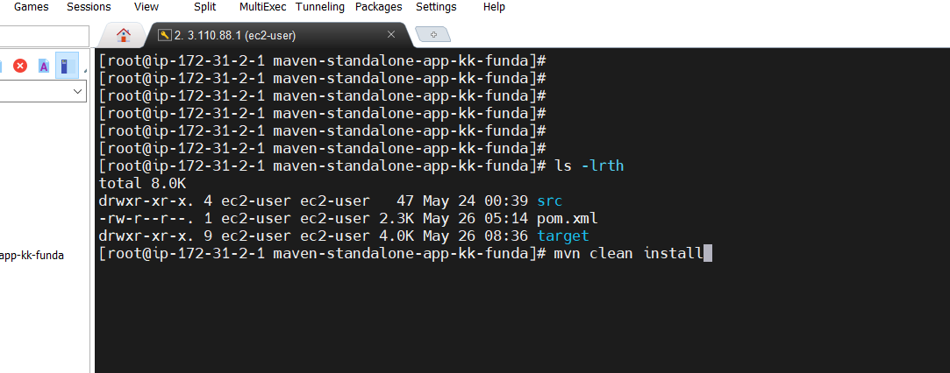
After executing the above command mvn clean install you can see in the below image
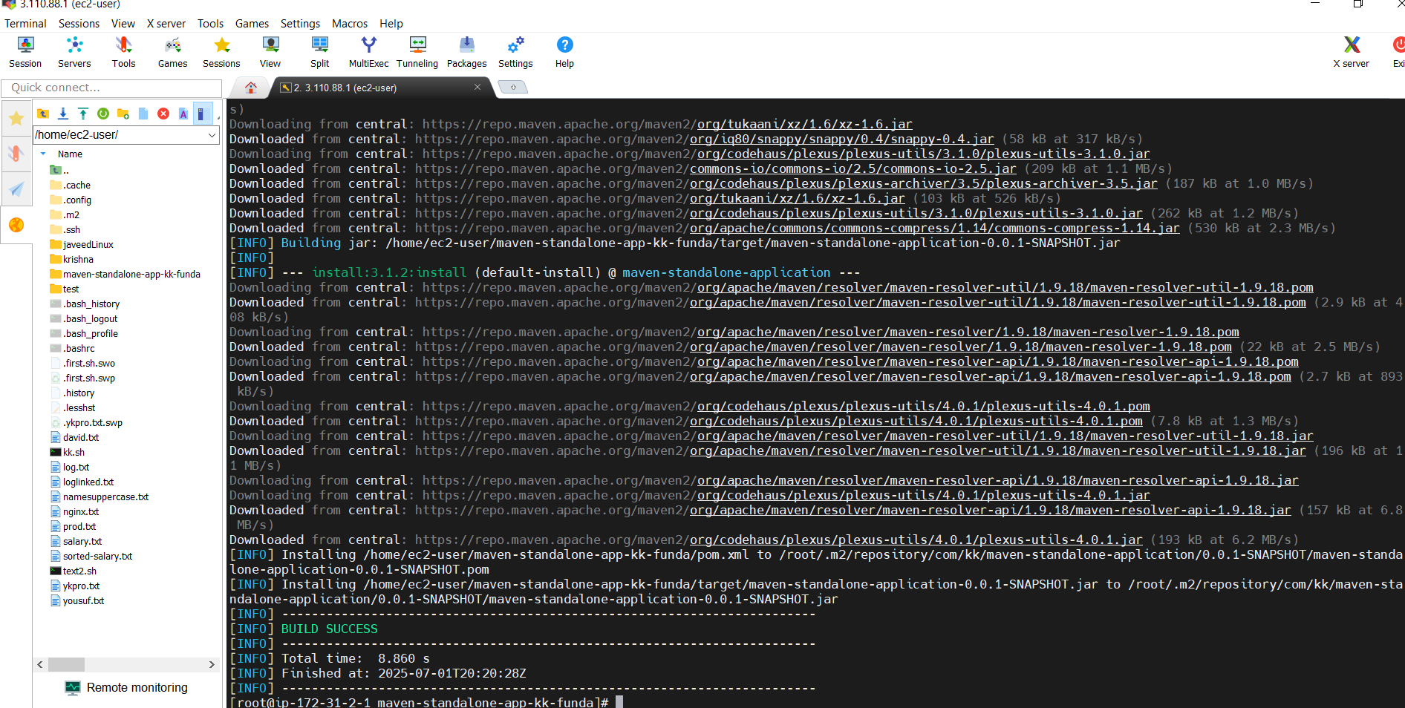
This command mvn clean install after executing will compile your code, package it, and generate a .war file in the target/ folder.
Navigate to target folder to check the war file by executing the command ls –lrth target/ as shown in the below image
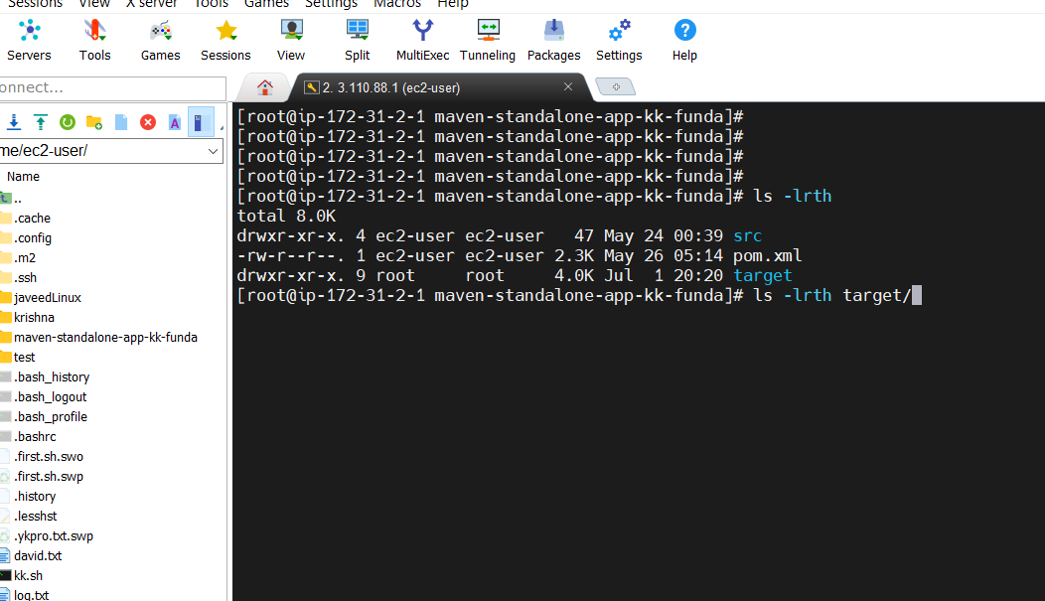
Unable to find .war file in my maven folder look I have not added source file ( at 20:00)
check the maven classes or notes gain.

